OLD BASFORD SCHOOL ALIEN AIDERS – QUESTIONS TO ASK YOUR CHILDREN WHEN READING
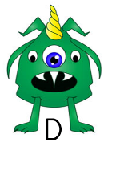  DEC THE DECODER | Which phoneme is that?  Can you sound out the word?  Say the phonemes.  Do you know another phoneme for that letter(s)?  Do you know the digraph (2 letters=1 sound)/ trigraph 3 letters=1 sound)?  Can you see a word inside the word?  Can you decode parts of the word?  This word is a tricky word and you can’t sound it out. Do you recognise it?
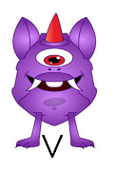  VIOLET VOCABULARY | What does the word _________mean in this sentence?  Can you read the rest of the sentence to work out what it means?  Find and copy a word which means__________.  What does this word or phrase tell you about the character/ setting?  Why is the word written in capitals/ bold letters?  Why do you think the author used that word?
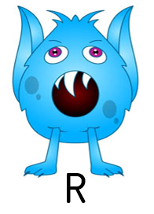  REX THE RETRIEVER | Who is the main character?  What time of day is it?  Where is it taking place?  What are they doing?
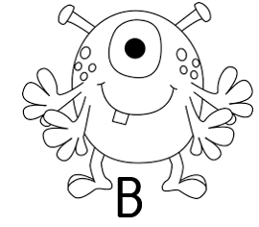  BERTIE BETWEEN THE LINES | Why do you think _________ was feeling______?  Can we work out how _________ is feeling?  Why do you think that happened?  Why do you think __________said that?  Can you explain why_________?  What do you think the author intended when they said___________?  How does __________make you feel?
  PETE THE PREDICTOR | Look at the book cover/blurb – what do you think this book will be about?  What do you think will happen next? What makes you think this?  What do you they are going to do next?  What do you think _______ is going to say?  What might happen if _________ ?  How will it end?
  EDNA THE EXPLAINER | How do you know ________?  Can you explain your answer?  What makes you think_____?  What did the character do to make you think?  Can you find the answer in the text?
  SAL THE SUMMARISER | Can you tell me what just happened?  Can you tell me what ______ just said?  What happened when we last read?  Can you summarise the beginning/ middle/ end of the story?  Can you tell me the first/ second/ last thing that happened?  Can you put these sentences in the order that they happened?
  CRAM THE CONNECTOR |   Do you know any other stories like this?  Do you know any other books by this author?  Do you know any other stories with a character like this?  Do you know any other books when this has happened?  Has anything like this ever happened to you/ someone you know?

