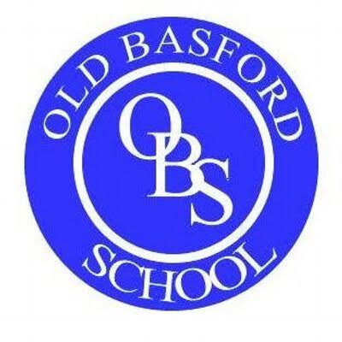
Impact and evidence of being an RSC Associate School 2022-2023
Old Basford School
Date and Event | CHILDREN AND YOUNG PEOPLE  Language acquisition and development: improvements in vocabulary, oracy, reading and writing. | TEACHERS  Teachers feel more confident and positive about teaching Shakespeare. | PARENTS  Parents are proud of and engaged in their children’s learning about Shakespeare. | THE SCHOOL  The rehearsal room pedagogy is adopted and applied across the whole school in primary schools and in both English and drama departments in secondary schools.
2nd September 2022  Whole School INSET day  Diary dates shared with the whole school linking to Shakespeare focuses.   |  | Impact:  - Teachers had time to think about Long Term Plans and make arrangements in their phase |  | Impact:  - Awareness and importance heightened  - Expectations that the whole school participate and engage  - Thoughtful and considered timeline  - Transparency – no hidden surprises or bolt-ons.
21st September 2022  RSC CPD for Nottingham schools on Twelfth Night  Introduction to an outline of the plot & characters |  | Impact:  - 2 new members of staff joined me on the training. Enabled them to have a positive first experience of Shakespeare in primary school.  - Training notes shared with staff. |  | Lead RSC Teachers planned units of writing and activities for all Nottingham schools. EYFS – Y2 and KS2 planning based on the rehearsal room pedagogy.
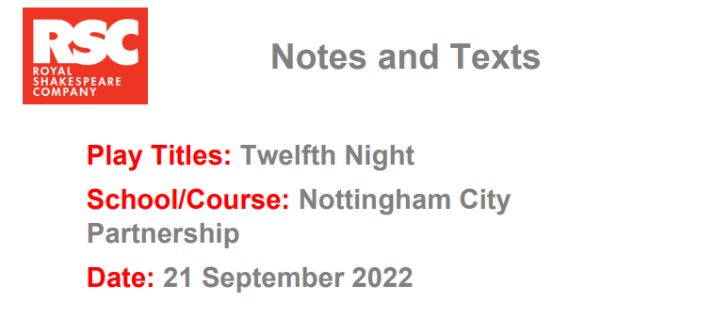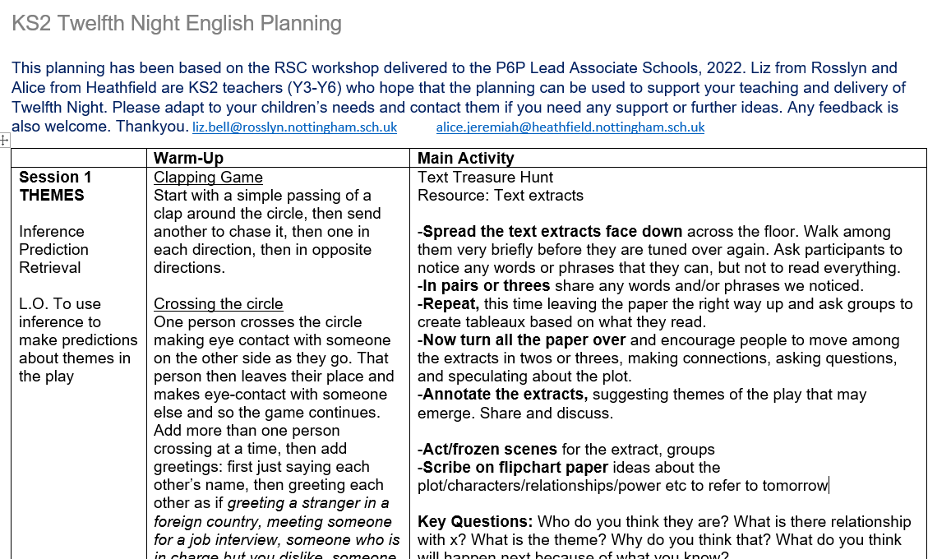
27th September 2022  RSC Ambassadors event for old and new pupil ambassadors and a teacher from each school at the Theatre Royal and Concert Hall.  Opportunity to see Ambassador films  37 Plays Introduction to Play writing workshops in schools with Andy Barrett | Impact:  - Ambassadors felt as if their time as an ambassador was validated- certificates shared at a later date  - The network of schools felt connected in sharing films and celebrating achievements  - The children were proud of their video showcasing our Shakespeare week in June 2022  - Children were motivated in the next stage of using language improving vocabulary, oracy, reading and writing by engaging with the 37plays. |  | Impact:  - Parents felt proud of their children being part of a wider network and collaboration
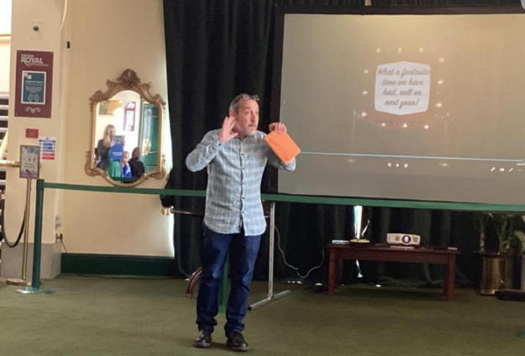
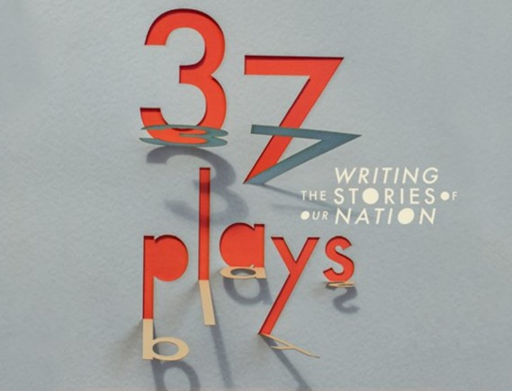
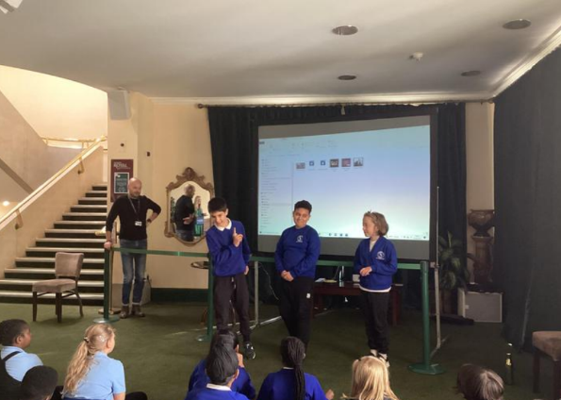
18th and 19th November 2022  ‘Connected’ event at the RSC, Stratford Upon Avon |  | Impact  - Teachers feeling connected with other lead schools from across the country  - Building relationships and sharing journeys; learning from each other  - Building confidence in ourselves; knowing that what we are doing and are part of makes a real difference to children’s learning and lives.  - Participation in a range of workshops: rehearsal room drama techniques, characterisation and creative writing.  - Discussion of development and future of RSC work in our cluster |  | Impact  All ideas and useful information were shared in our schools with other teachers and the school’s literacy lead
2nd December 2022  First Encounter’s production of ‘Twelfth Night’ at Bluecoat Beechdale Academy | Impact  - 20 Y5 & Y6 OBS children watched the performance and had their first encounter of the new play  - An ex OBS pupil and ex drama club student (who had performed in Macbeth) was one of the characters in the production) | Impact  - Watching enabled me to have more of an idea of the play.  - Gave me ideas for our own production later in the year.
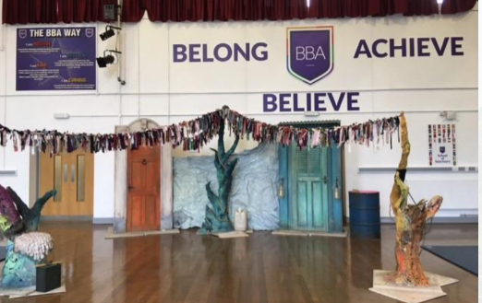

9th December 2022  Nottingham TRCH performance of Snow White | Impact  - 64 Y5 children went to Nottingham Theatre Royal to watch the pantomime for FREE |  |  | Impact  This was an additional perk of being an RSC associate school and was totally free to the school.
10th December 2022  Nottingham Playhouse production of Pinocchio | Impact  - 120 KS1 children were able to watch a FREE production in school  - The children enjoyed the storytelling experience and were mesmerised. They sang danced and laughed throughout! |  |  | Impact  This was another additional perk of being an RSC associate school and was totally free to the school.
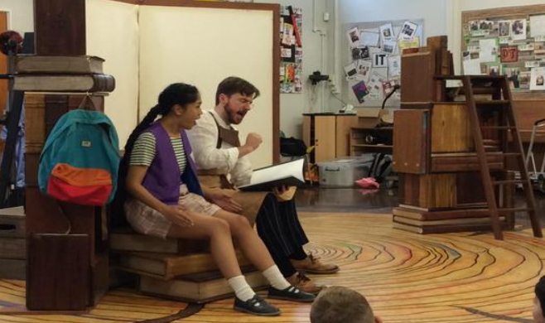

23rd January 2023  RSC Ambassador workshop with Lizzie Hopley from the RSC based on the 37 plays | Impact  - Children exploring themes and ideas of story and plays through drama techniques, oral storytelling and creative writing  - Children participating in an event with other Nottingham school children sharing vocabulary and focusing on developing their literacy skills  - One child returned the next day with a story she had written inspired by the workshop
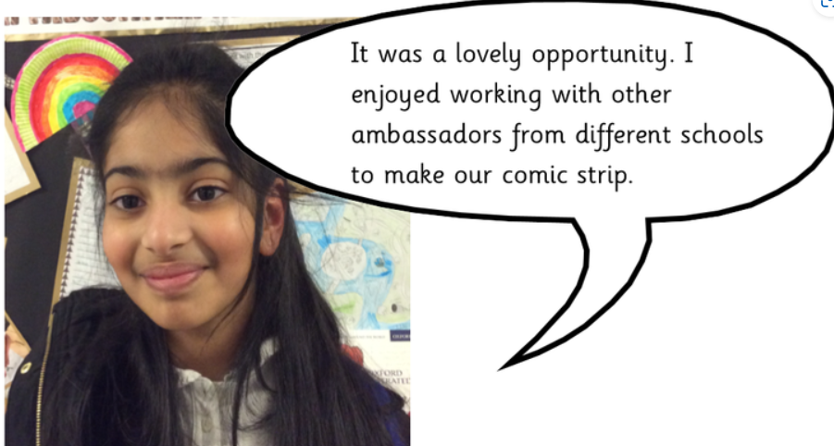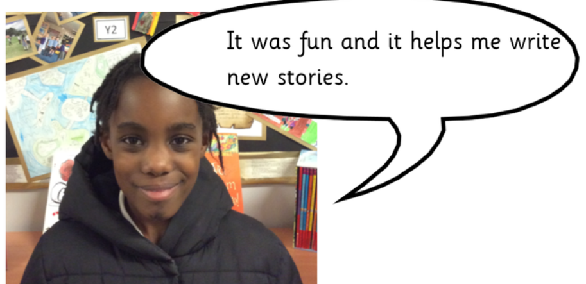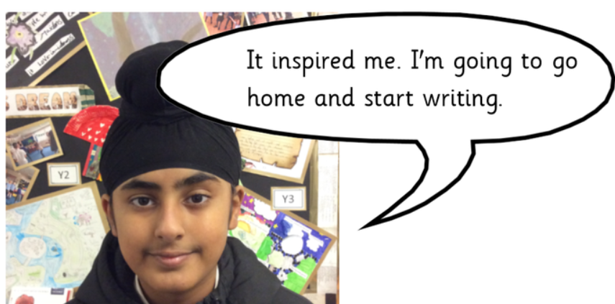
24th January and 14th February 2023  Writing workshop with Andy Barrett focus on ’37 plays’ | Impact  - 14 Y6 greater depth writers had drama, storytelling and playwriting input with the author  - Impact on vocabulary, sentence structure, authorial voice
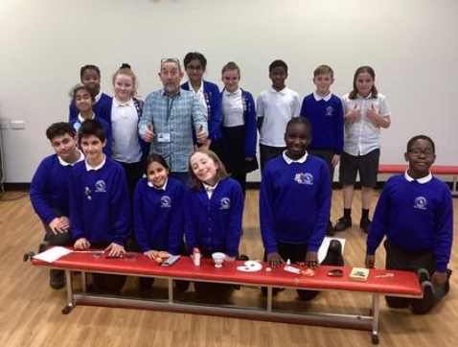

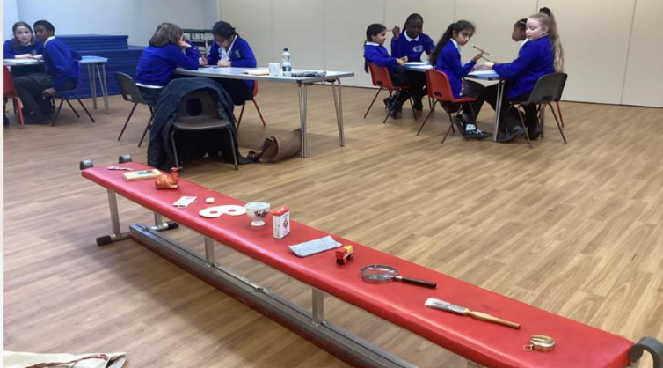
10th February 2023  Ambassador workshop at the TRCH | Impact  - Consolidation of roles and responsibilities  - Increasing the importance of their role
27th March RSC INSET  Performance focused INSET for teachers leading the showcase |  | Impact  - Preparation for the Summer Playmaking Festival.  - Useful for myself as ‘director- voice projection, breathing, staging techniques  - Attended by Liz Kelly- literacy lead to help with her understanding of RSC rehearsal room drama techniques |  | Impact  - Literacy lead could consider drama techniques that would supplement OBS literacy teaching outside of Shakespeare week  - Gave writing techniques- vocabulary generation, writing iambic pentameters
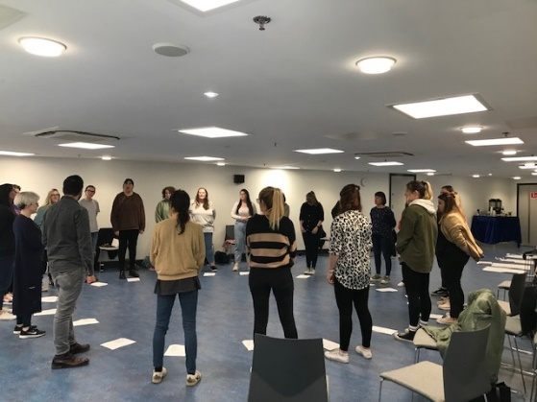
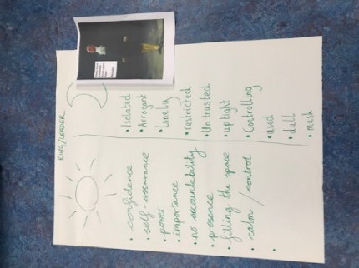
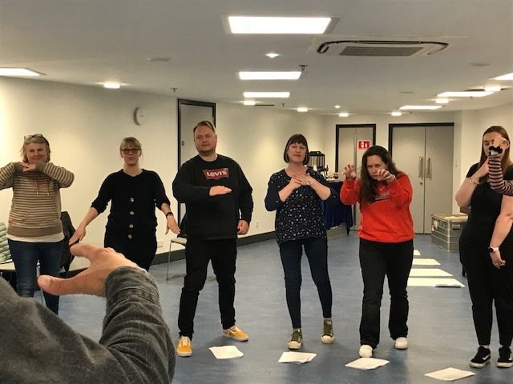
19th April 2023  Shakespeare’s Birthday assembly |  |  |  | Impact  - Heightened awareness for Y1-Y6  - General information about Shakespeare shared  - Consolidation of prior knowledge  - New knowledge gained
FREE TICKETS to see Julius Caesar |  |  |  | - Staff took advantage of the offer as members of the RSC Lead school
!7th May 2022  Staff Workshop – Twelfth NightEYFS-Y6 staff learnt about the rehearsal room techniques in an immersive workshop |  | Impact  - Shared resources  - Teachers felt positive taking part in the workshop finding it fun and ‘being the children’.  - The workshop consisted of small golden nuggets which were easy to replicate in their own classes.  - Teachers given ideas for drama lessons- confidence increased  - I demonstrated writing opportunities connected to the play and ones that could be used outside of Shakespeare week  - More confidence in iambic pentameter- wrote their own in groups (see photo below) |  | Impact  - Differentiated resources and approaches to be used across F1-Y6  - Expectation given to have a whole week off timetable  - Expectation to produce at least one piece of writing F2-Y6
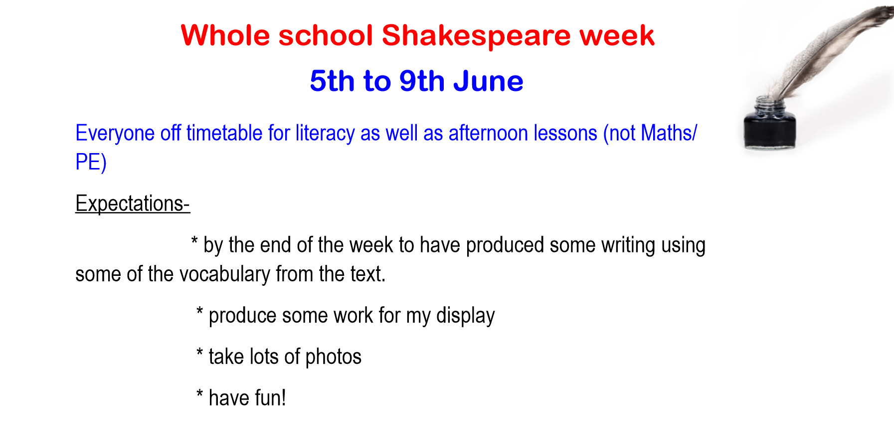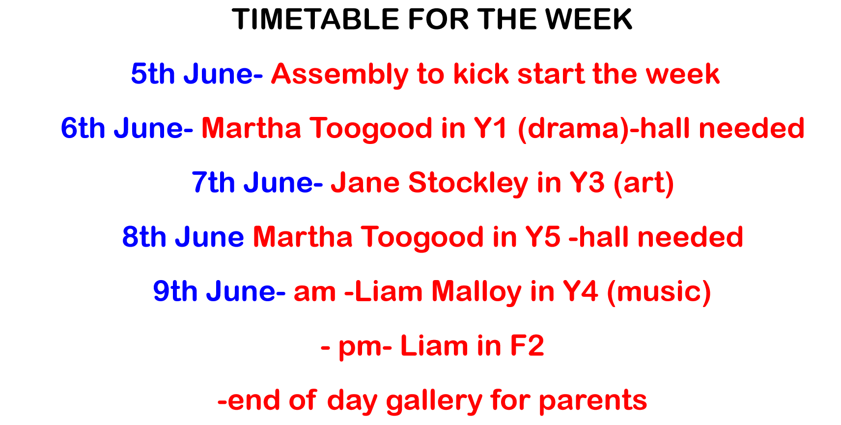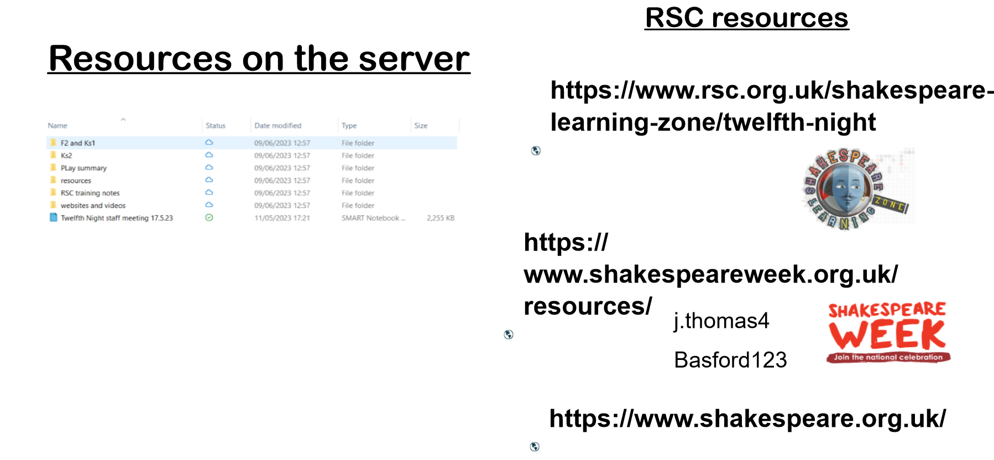
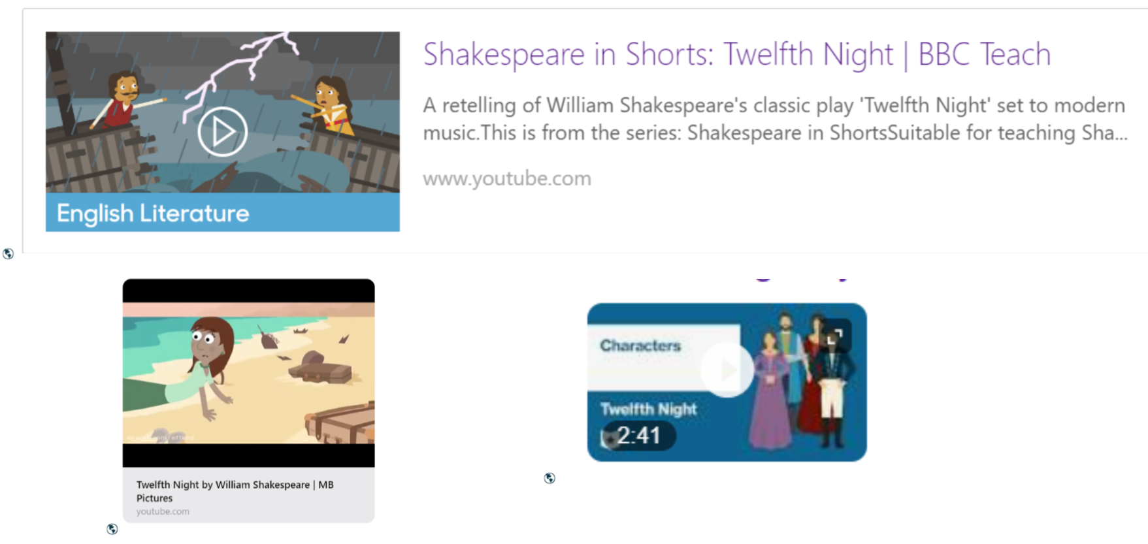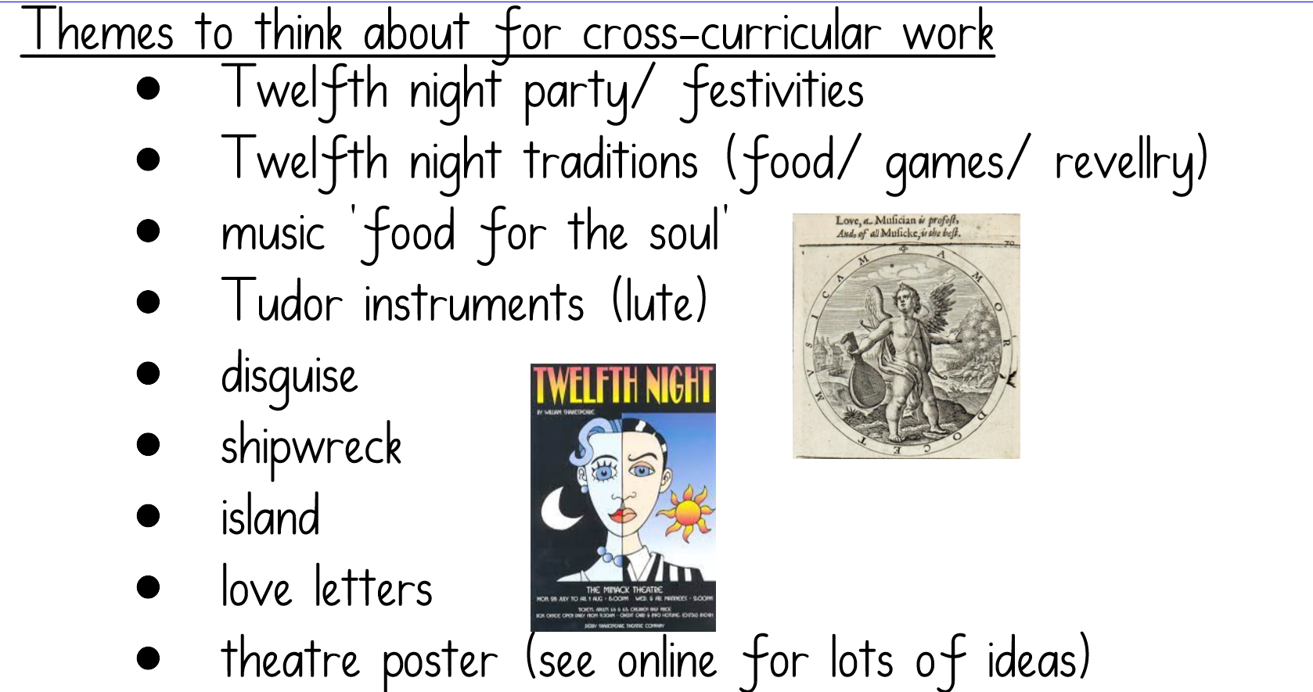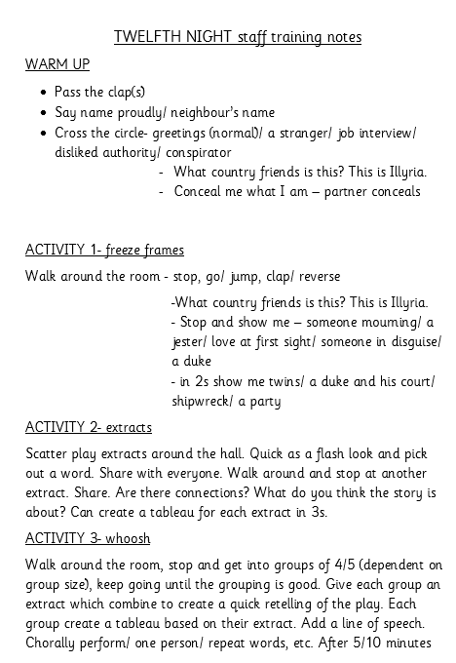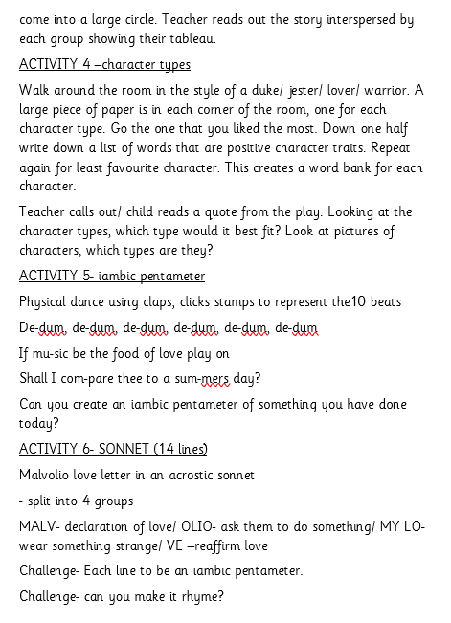
5th-9th June 2023  Shakespeare Week at OBS- Twelfth Night Nursery to Year 6 | Impact  - Children rehearsing quotes orally, chorally, with confidence  - Children are able to ‘show’ how characters feel  - Some children use inferences and predictions about characters based on what they know  - Y1-Y6 each child produced a piece of writing- KS2 using the original text in their writing  - F2 and Y4 explored the play through music with Liam Malloy  - Y1 and Y5 explored the play through dram with Martha Toogood  - Y3 explored the theme of ‘stand out from the crowd’ with visual artist Jane Stockley  - Y1-Y3 produced a group art project based on the storm which is now on display on the path leading to school  - Ambassadors helped with end of week gallery and interviewed the parents | Impact  - CPD for f2, y1, y3, y4 and y5 staff who had associate artists in their class delivering music, art and drama  - Teacher’s expectations of children’s abilities surpassed- raise expectations in other areas of the curriculum | Impact  - Parents invited to look at a gallery of work at the end of the week to celebrate and raise the profile of OBS and RSC work- well attended.  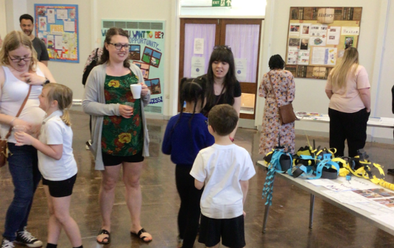 | Impact  - Whole school focus  - Whole school off timetable  - Cross-curricular work  - Whole school assembly introducing the text- explored the theme of celebrating ‘twelfth night’ and a brief overview of the plot  - All children immersed in the play and text of Twelfth Night using rehearsal room techniques  - All children able to name characters and something they remember about the play  - All children produced a piece of writing  - Prominent display of work celebrating the week
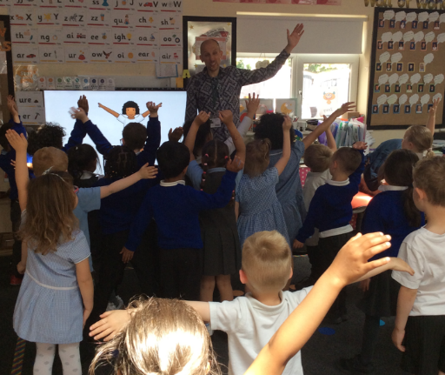
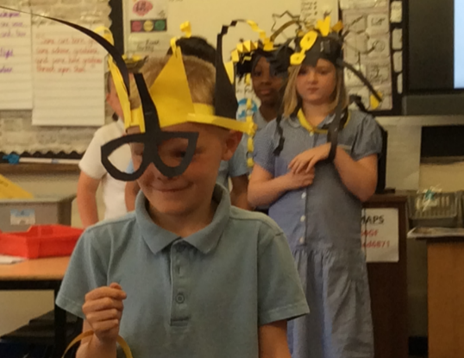
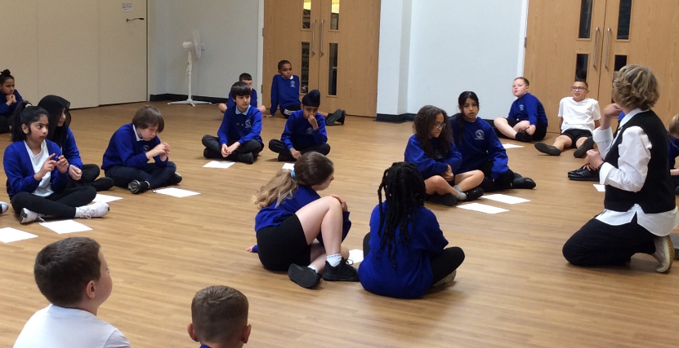

2nd May- 19th June 2023  Weekly drama club after school meetings | Impact  - 20 Y5 and Y6 children learn, practise and rehearse a scene in preparation for Regional Playmaking Festival.
22nd May and 9th June  Helen Goodbarton – director mentor visits | Impact  - Scene rehearsal improving staging  - worked on characterisation, voice projection and breathing techniques | Impact  - CPD for Jayne Thomas improving directing techniques
26th and 27th June 2023  RSC Regional Playmaking Festival at TRCH- Twelfth Night | Impact  - Performing in front of an audience of almost 1000  - The children were overwhelmingly positive about the experience  - Some said they were anxi0ous beforehand but felt good about themselves afterwards.  - I asked them ‘why do you think it is important to perform at a theatre?’ They talked about it being ‘fun’, ‘it helps with our confidence’, ‘to be proud of themselves’, ‘it’s an opportunity everyone should experience’, ‘it’s a once in a lifetime opportunity’, ‘you get to express yourself’.  - Experiencing the technical side of theatre gave them insight into other career opportunities |  | Impact  - 40 parents came to see their children perform- pride in their children  - not necessarily theatre goers  - not necessarily knowledgeable about Shakespeare  - Recording on website for further viewing/ show to extended family | Impact  - 55 children came to watch the show-opportunity to experience the theatre/ opportunity to see the whole play  - The children performed the scene to the whole school
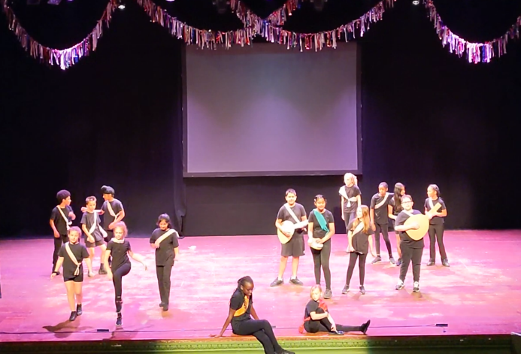

17th July 2023  Nottingham Playhouse perform Twelfth Night at OBS | Impact  - 120 children watched the performance  - Key quotes given out beforehand for the children to listen out for  - Children could recall the main events and characters from the play
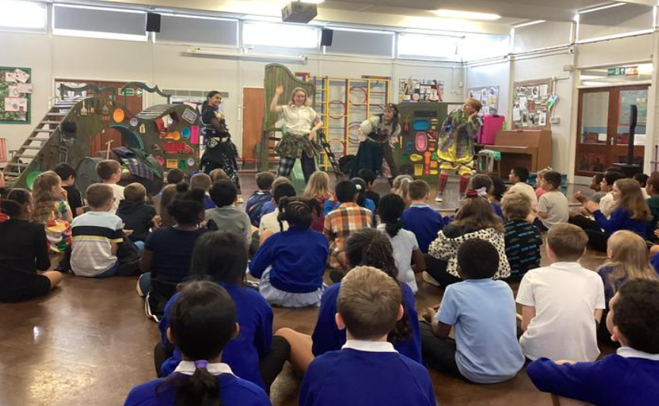
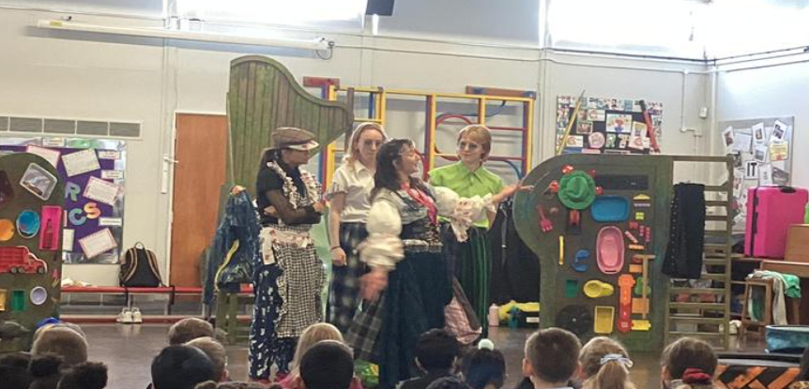
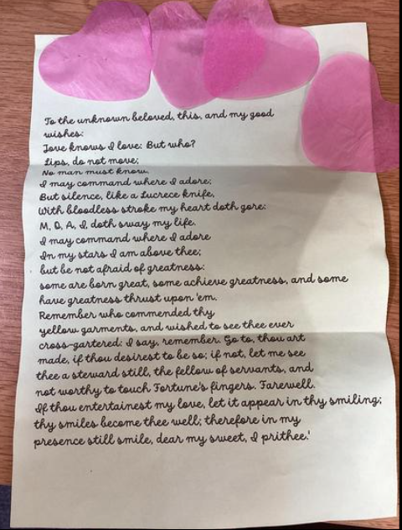
21st July 2023  RSC and drama approaches with SEND children | Impact  - Ensures inclusion for all children at OBS | Impact  - CPD for 2 teaching assistants who work with children with SEND and/ or Early Years  - Sensory approaches to teach Shakespeare  - Approaches to be used beyond Shakespeare week
Live theatre 2022-23 | Impact  399 children have experienced live theatre in school or at a theatre for FREE thanks to our association with the RSC

