Capturing evidence of impact and telling our story 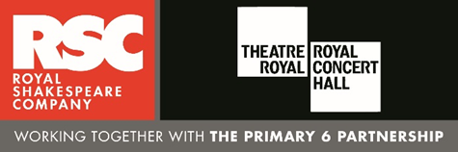As the Associate Schools programme develops, we are gathering more and more compelling evidence about the impact on young people, teachers, schools and communities. This takes the form of anecdotal stories, quotes, statistics, pieces of work (especially written) and exam results. Together they build a powerful evidence base that we can all use to advocate for the incredible work that is taking place in our schools and theatres and for the approaches that we are passionate about.

In your role as a Lead Associate School, it is essential that you capture the impact of the work of both your school, and your Associate Schools. To share that with your theatre partner, Associate Schools, RSC and other stakeholders. The RSC has its own programme of research and evaluation, which we share with funders and to influence policy makers and from time to time you may be asked to participate in research. We cannot do this without you and the most significant data will be the stories and statistics that you are able to collate and share.

In order to capture and record a robust picture of your work, you will need to gather a variety of data, which may include:
- The activities and events that take place and where
- The reach - who took part i.e. number of teachers (including which school) and/or students (including year group), number of parents etc.
- Reflections in your journal
- Observations of your lessons and your colleagues’ lessons
- Feedback comments or quotes (collected on feedback forms, comments cards, through interviews, in conversation etc.)
- Any data you collect in your normal course of work that demonstrates pupil progress and attainment
- Any evidence that you see that reflects a change in pupils’ attitudes to Shakespeare and theatre
- Notes and feedback from any CPD you run for your colleagues
- News and advocacy around the programme e.g. school newsletter, press cuttings etc.
- Any particularly illustrative stories about the impact on students, classroom practice and the wider community. For example, a student whose response to an activity was new and surprising, a previously reluctant teacher who used the work in her classroom with positive results, the response of parents and so on
- Photographs / video recordings of your events.
Capturing evidence of impact and telling our story- 2021-22
OLD BASFORD SCHOOL
Date | What happened? | Impact
7.10.2021 | Free tickets available for the matinee performanace of Bedknobs and Broomsticks at Nottingham Theatre Royal. | 263 tickets were distributed to families of children at OBS. Almost all children said how ‘amazing’ the production was. Many parents expressed their thanks in person and another said that it is her first theatre trip with her 5-year-old daughter and they were 'making memories together'.
11.10.21 | RSC Teacher Develpoment Day- Theatre Royal  A whole day of A Midsummer Night’s Dream INSET for Nottingham Associate Schools. OBS teachers- Jayne Thomas (lead teacher & Y2), Charlotte Lloyd (F2) and Clare Tindsley (Y4).  Lots of practical resources and ideas given out for delivery of drama based activiites to introduce parts of MSND text. | Excellent, enjoyable and very useful practical day for all teachers involved. Ideas to support lead teachers in planning teaching blocks and to be delivered in staff meeting in school in preparation for MSND week in June 2022.
18.11.21 | Free tickets available for the matinee performanace of School of Rock at Nottingham Theatre Royal. | 230 tickets were distributed to families of children in Y4-Y6 at OBS. The chilkdren loved the experience and loved the interactive feel to the performance.
1.12.21 | Ambassador training | 3 Year 5 children were selected to be a Shakespeare Ambassador for OBS. During the afternoon at the theatre, they met with the other ambassadors and learned some filming and editing techniques in preparation for their task of making a 3 minute video about Shakespespeare at OBS.
9.12.21 | MSND Planning | I met with another Lead Associate teacher to plan a two wek block on MSND using the rehearsal room techniques that we learned during our RSC Teacher Development Day. I also used some of the ideas we had been given during our training for ‘Dream 16’. We planned a block of lessons for a week based on ‘the woodland’ and another week based on ‘The Fairies’.
25.4.22 onwards | Drama Club | 24 children from Y4-Y6 are in drama club. We met weekly after school and quickly got to work on our 5 minute performance about ‘Magic and Mayhem’ for the ASP Regional Playmaking Festival. I selected the opening scenes of ‘The Tempest’.
17.5.22, 7.6.22 & 21.6.22 | Rehearsals for RSC Associate Schools Regional Playmaking Festival | A practitioner from Nottingham Playhouse came into school to help direct OBS’ performance piece for the festival.
18.5.22 | OBS Staff Training – delivered by Jayne Thomas to teachers and teaching assistants of Y1-Y6, inlcuding the Head teacher.  Ideas, resources given out to staff. A practical staff meeting using the rehearsal room techniques demonstarted during the RSC training in October.  Charlotte Llyod (F2 teacher on the initial training day) delivered the training to the FS staff. | Some of the staff were a little reticent to take part in some of the drama activities but soon ‘warmed up’ and all joined in with enthusiasm. Many of the staff were thankful for the ideas and really enjoyed the activities finding them fun as well as educational. Many showed ‘hidden talents!’  The planning form the lead teachers for Fs&KS1 and Y3-Y6 was shared as well other ideas for cross-curricular activities.  Great ST tonight - just what I needed.  Also was chatting to Helen (Y6) whilst I was in her acting/freeze frame groups.  We came up with up with lots of ideas for writing linked midsummer night’s dream.  The favourite of which seemed be to either a poem or a Setting description of the forest ( with two contrasting verses/paragraphs) 👍👍👍  -VICKY SHAW OBS HEAD TEACHER
Week beginning 6.6.22 | SHAKESPEARE WEEK @ OBS  Whole school (Nursery-Y6) week A Midsummer Night’s Dream. The whole school is ‘off timetable and the expectation is that all lessons (exceot for maths) are linked to the play. | 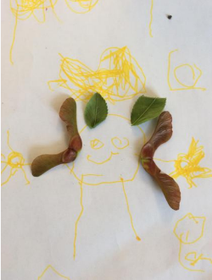  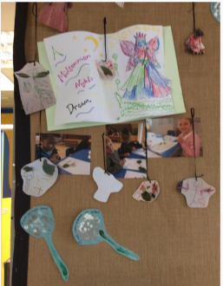  F1- In nursery they learned all about the fairies in  the play and thought about what fairies like to do. They had a fairy hunt around the nursery and created their own fairies out of leaves and flowers. They talked about what they would do if they were fairies and what spells they would cast.
Week beginning 6.6.22 |  | 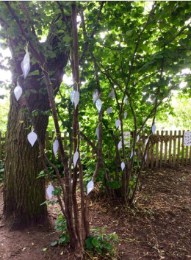  F2- They discussed the woodland setting, thought about the magical characters that could live there and performed drama. They all made a wish, wrote them down and created a 'Fairy Wishing Tree' in the FS garden.
Week beginning 6.6.22 |  | Y1- In drama they recreated the creatures in the lullaby and then wrote their own lullabies. They made fairy potions in science, turned themselves into fairies in IT and made  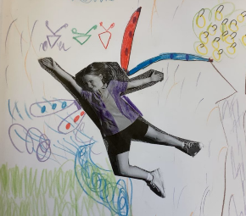  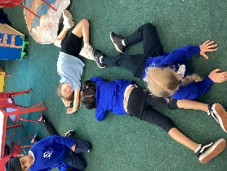  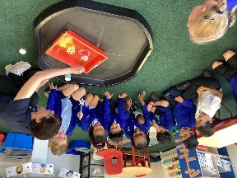  and fairy doors in DT.
Week beginning 6.6.22 |  | 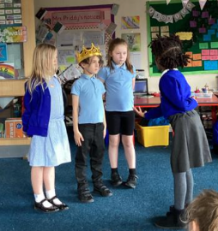  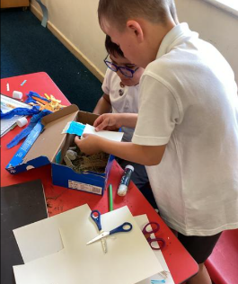  Y2- They performed lots of drama about the woodland settings which led to a written piece- a poster warning people of the dangers in the ‘Midsummer Woods’ and all of the creatures there. (In the following week  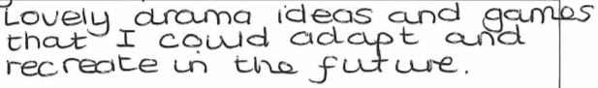  the children continued to use many of the Shakespearean phrases from the text in their other writing -lasting effect). Martha Toogood also worked with the chilren on drama based on scenes about the fairies. They children loved all of the drama based work. Cross-curricular work- fairy doors and fairy home dioramas.  NIC RICHARDS- CLASS TEACHER
Week beginning 6.6.22 |  | 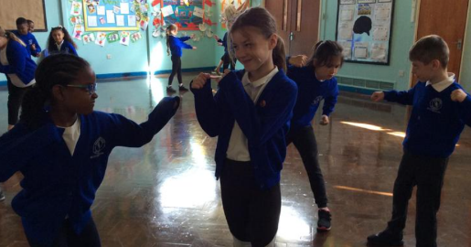  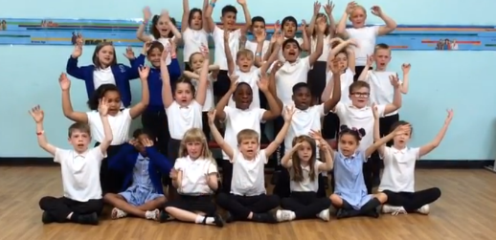  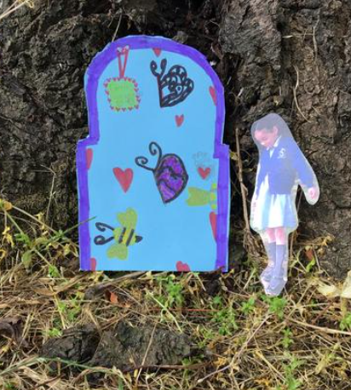  Y3- They adapted the planning for KS1 and performed lots of drama. They explored the woodland setting and ‘experienced’ walking through the dischordant and harmonious forests. They acted out different characters from the play in their different settings. They learned the setting descriptions by heart and performed chorally with actions. They were inspired to discover the school grounds ‘up close’ and then made their own fairy doors.
Week beginning 6.6.22 |  | 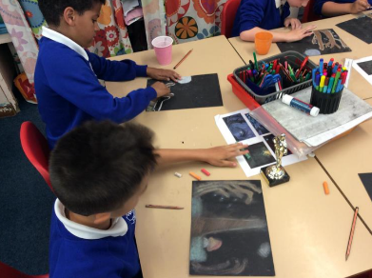  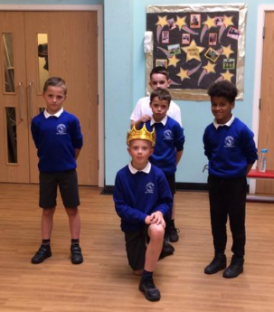  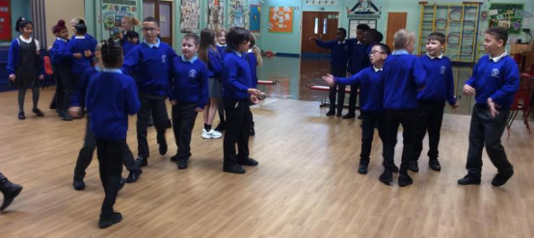  Y4- Martha Toogood began the week and introduced Y4 to the characters and settings through lots of enjoyable rehearsal room techniques. The children then followed up this with a written descriptive piece about the woodlands. In art they used the descriptions to inspire their chalk pastel drawings of the atmospheric woodland.
Week beginning 6.6.22 |  | 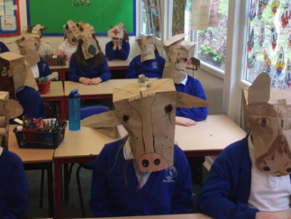  Y5- Jane Stockley worked with the children on characters and props. They made their own ‘donkey head’ for Bottom. The children used the descriptions  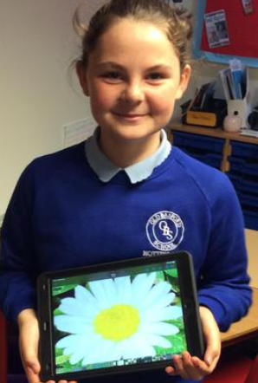  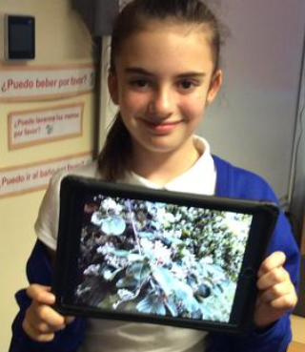  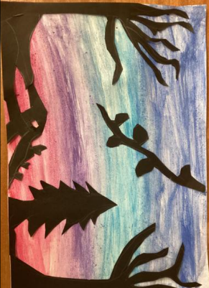  of the woodlands to inspire their photography of the school plants and trees, making them look sinister or happy. In art they created silhouettes collage and paintings of the woodland scenes.
Week beginning 6.6.22 |  | 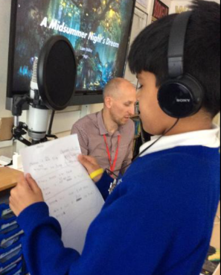  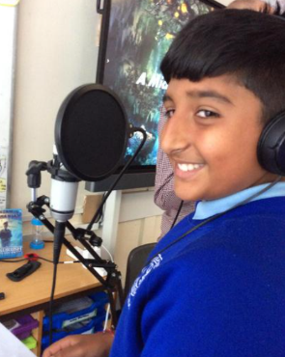  Y6- Liam Malloy worked with Y6 children. They had a song writing workshop based on the characters from the play. The children wrote their own lyrics  and anyone brave could perfom a solo. Liam recorded  and edited the song. The children loved the opportunity  as this was unique and something they had never before experienced…‘life is full of surprises the moon shines through the trees...’
Week beginning 6.6.22 |  | Ambassadors- During the week the ambassadors filmed different classes and took photographs of the different activitoes to create a montage for the school website. They interviewed younger children in school and helped them to fill in a questionnaire about Shakespeare and drama. At the end of the week they helped to deliver a whole school assembly which included information about Shakespeare and a quiz to assess the children’s learning.
27-28.6.2022 | RSC Associate Schools Regional Playmaking Festival | Twenty four drama club childrrn (Y4-Y6) performed an edited version of Act 1 Scene 1 of The Tempest as part of the ‘magic and mayhem’ themeof the festival.  Jayne Thomas’ thoughts-  The Tempest is becoming a favourite of OBS and one that the children and I are very familiar with. Our school studied this play last year and having watched an outdoor performance by Nottingham Playhouse, the children have fond memories. The opening scenes of The Tempest perfectly encapsulate the theme of ‘magic and mayhem’. A ship is sailing through a violent storm created by the powerful hands of the magician Prospero with the help and trickery of Ariel, his spirit servant. The crew and passengers are tossed and turned, believing that all is lost and they will perish. Fortunately, despite the turmoil and confusion of the tempest, Ariel ensures no harm is done and all are washed up on the shore.  The rehearsals were supported by Nottingham Playhouse practitioner, Ben McPhereson.  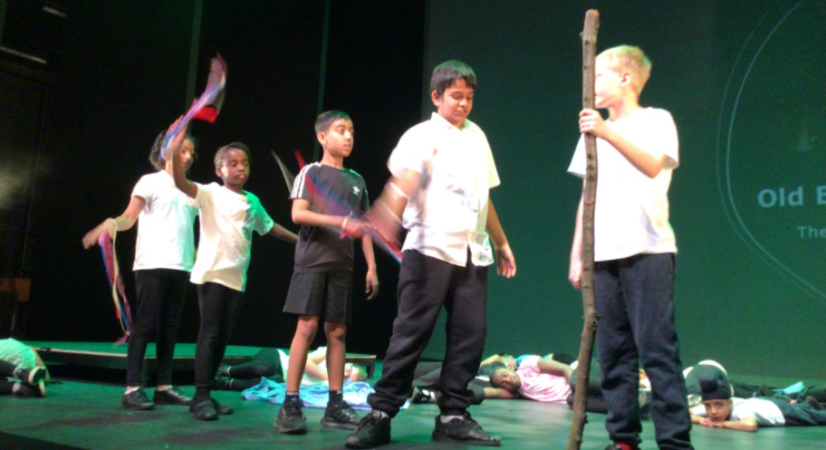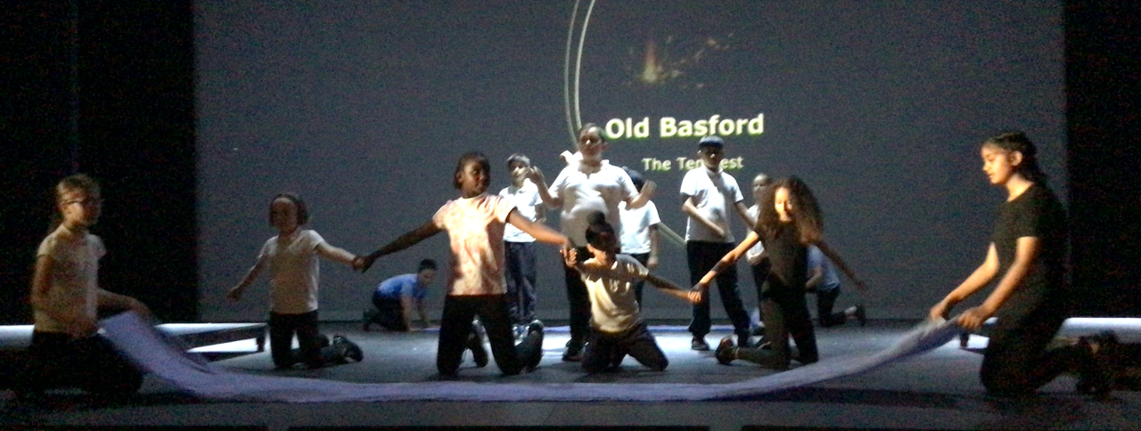  “Can I pass on a massive thank you to the extraordinary Mrs Thomas - we thoroughly enjoyed watching the school performance at the Nottingham Playhouse and it was clear to see such a lot of hard work that had gone in to making that happen. Another great opportunity for the children and we are bursting with pride to see our son on the stage”. (Isaac’s mum)  “I just wanted to thank you, Jayne, for inviting me to the RSC Showcase today. Even better than I remember the last one was and the OBS pupils represented the school brilliantly.  Thank you so much for the huge amount of work that you put into these events, the pay-off being the life-long memories that the pupils and parents will have as a result, and who knows, perhaps a burgeoning love for Shakespeare?” (David Lawson Co Governors)
8.7.2022 | Nottingham Playhouse ‘The Dream Tour’ | This was an amazing experience for our Y6, Y2, grama club and Shakespeare ambassadors to watch. The children loved it, were engaged and enthralled throughout the play. There were lots of times for laughter and the children could spot words and phrases that they had heard from their work in Shakespeare week “spangled starlight sheen” “haunted grove”. One teacher said that she had seen several interpretations of A Midsummer Night’s Dream but had “never seen one as good”.

